1. Create an Order Quote

|  |  |  |
| --- | --- | --- |
| **Use Case Name** | Create a quote for an order | |
| **Scenario** | Sales Representative creates a new quote for an order | |
| **Triggering Event** | Customer requests a quote for an order. | |
| **Brief Description** | Customer requests a quote for an order. Sales Representative creates a quote based on the order. The quote is created by the system based on the base price for the assay plus the average price for similar compounds. If the compound has never been used before, then the price will be given based on the maximum labor cost plus the base price for the assay plus a margin for materials. | |
| **Actors** | Sales Representative | |
| **Related Use Cases** | Created an order | |
| **Stakeholders** | Management, Sales, Customer, Lab | |
| **Preconditions** | None | |
| **Postconditions** | Sales Rep can proceed with creation of order at customers request | |
| **Flow of Events** | **Actor** | **System** |
| 1. Sales Representative starts a new order quote 2. Sales Representative enters assay types and quantity 3. Sales Representative finishes the order quote 4. Sales Representative enters contact info | * 1. prompt user to select assay type   2. calculates the average price of items   3. prompt the user to finish the order quote   4. Prompt user for customer contact info   5. System emails quote to customer   6. System saves quote and contact info to business lead |
| **Exception Conditions** | 3.1 User does not want to give contact info. In this case don’t save the quote | |

4. Create an Order

|  |  |  |
| --- | --- | --- |
| **Use Case Name** | Create an order | |
| **Scenario** | Sales Representative creates a new order | |
| **Triggering Event** | Customer contacts Sales Representative with order information to create an order | |
| **Brief Description** | Sales Representative creates a new order for a customer. | |
| **Actors** | Sales Representative | |
| **Related Use Cases** | Create an order quote | |
| **Stakeholders** | Management, Sales, Customer, Lab | |
| **Preconditions** | Customer needs to have an account | |
| **Postconditions** | Lab workers are able to schedule assay for completion. | |
| **Flow of Events** | **Actor** | **System** |
| 1. Sales Representative selects customer from customers list  2. Sales Representative starts a new order  3. Sales Representative enters assay types and quantity  4. Sales Representative finishes the order | 1.1 Display customer information  2.1 Prompt user to select assay type  3.1 Display quoted price for assay  4.1 System authorizes order and sends to be scheduled  4.2 System saves order with Work Order ID number and displays work order ID number  4.3 System sends email confirmation to customer with WO ID number |
| **UpException Conditions** | 2.1 Customer wants to cancel order and Sales Representative cancels the order | |

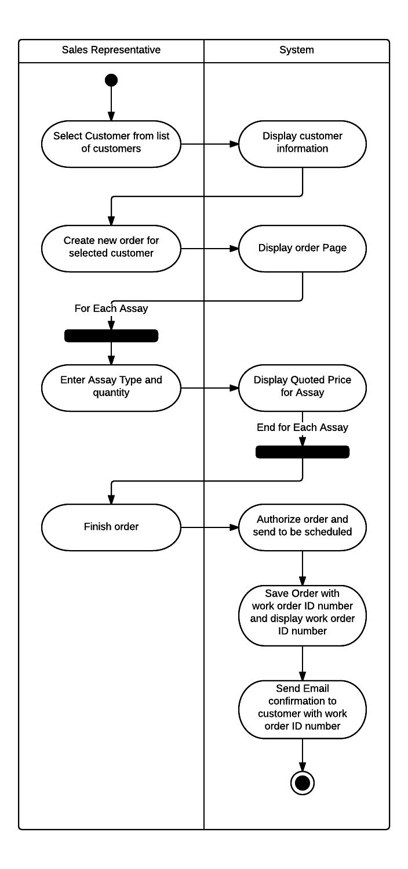

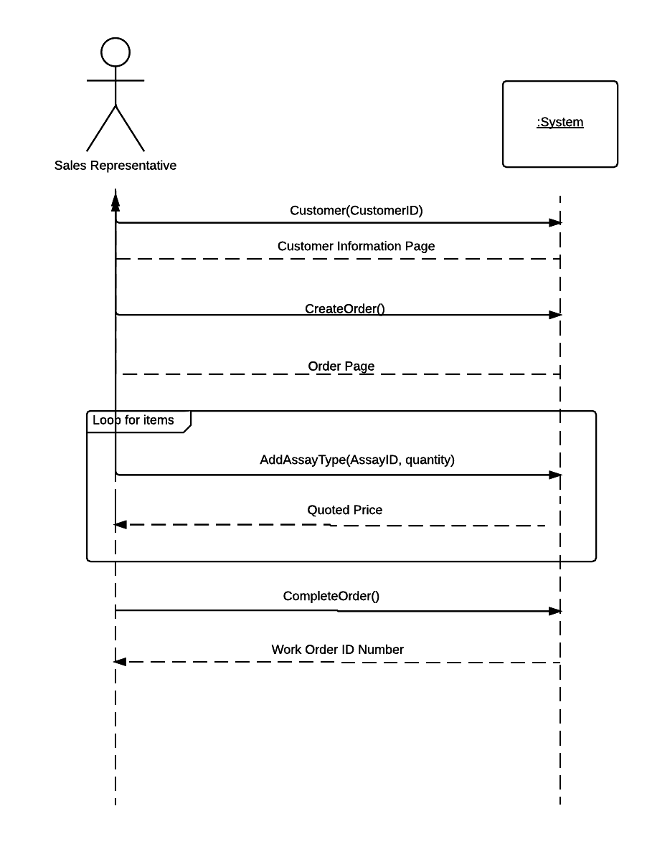

17. Update Hourly Charge Rate

|  |  |  |
| --- | --- | --- |
| **Use Case Name** | Update Hourly Charge Rate | |
| **Scenario** | Management wants to update the Hourly Charge Rate for Assay | |
| **Triggering Event** | Executive Decisions | |
| **Brief Description** | Management can change the hourly charge rate that is applied to all Assays | |
| **Actors** | High Level Management | |
| **Related Use Cases** | None | |
| **Stakeholders** | Management, Customer | |
| **Preconditions** | Management has a reason to change the hourly charge | |
| **Postconditions** | Hourly Charge is updated and applied to future orders | |
| **Flow of Events** | **Actor** | **System** |
| 1. Management selects hourly charge rate from billing dropdown menu  2. Management submits hourly charge r  3. Confirm Hourly charge rate change | 1.1 System displays hourly charge rate  2.1 System prompts user to confirm change  3.1 System saves Hourly Charge Rate |
| **Exception Conditions** | 2.1 Management does not choose to confirm, and hourly charge rate is not changed. | |

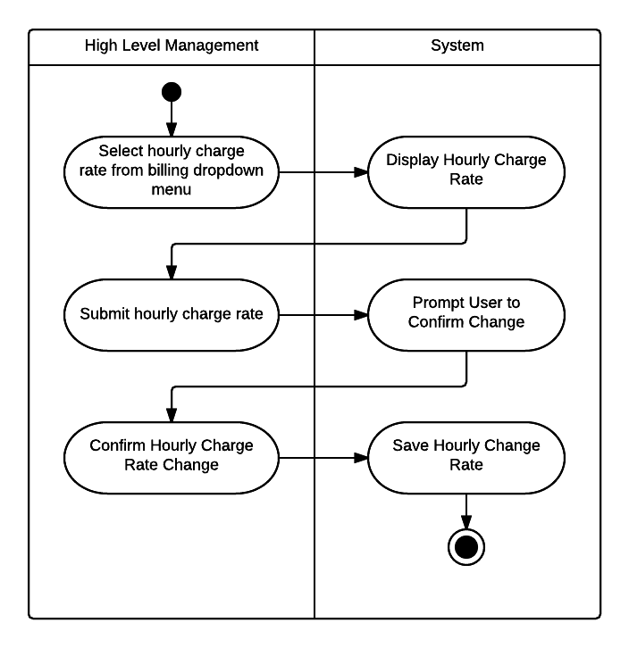

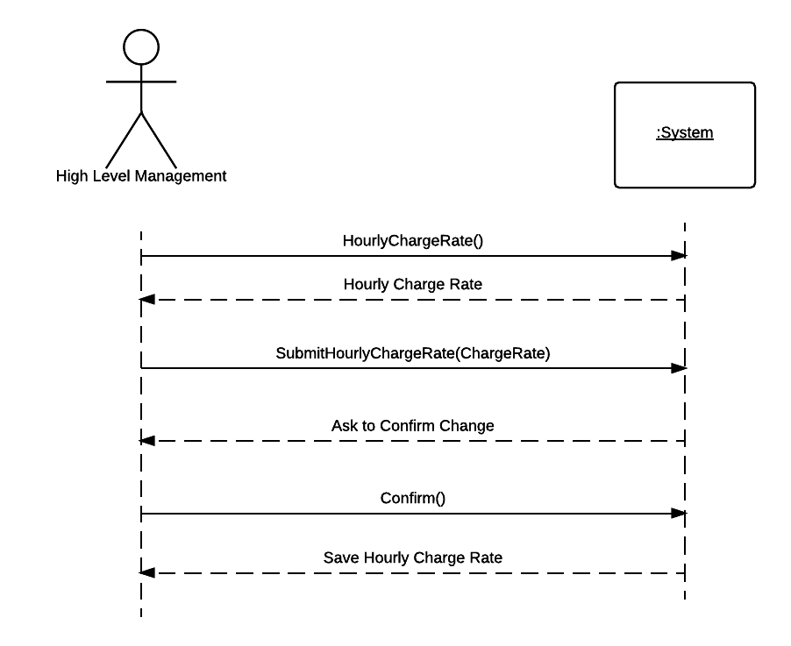

19. Update Assay Work Order Status

|  |  |  |
| --- | --- | --- |
| **Use Case Name** | Update Assay Work Order Status | |
| **Scenario** | Lab workers update Assay Work Order status to see the progress of the assay | |
| **Triggering Event** | Steps in the Assay are finished | |
| **Brief Description** | When a Lab worker gets the compound for a new assay he will change the status. Then when it is scheduled and pending tests it will be changed, then when the tests are completed it will be changed again. There will be other steps as well per the progress of the Assay | |
| **Actors** | Lab Worker | |
| **Related Use Cases** | View Assay Work Order Status | |
| **Stakeholders** | Lab Worker, Lab Manager, Management | |
| **Preconditions** | The next step in the work order has been completed | |
| **Postconditions** | The Assay work order status is accurately up to date, and can be seen by the customer, sales, and office managers | |
| **Flow of Events** | **Actor** | **System** |
| 1. Lab Worker selects what work order to view  2. Lab worker updates progress of work order status and clicks save | 1.1 System displays all assays associated with work order  2.1 System saves info and refreshes screen with updated progress of work order status |
| **Exception Conditions** | 2.1 Lab worker does not save. Work order status is not updated. | |

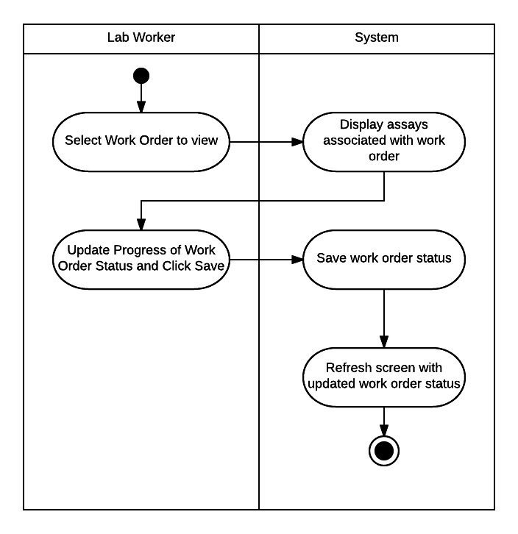

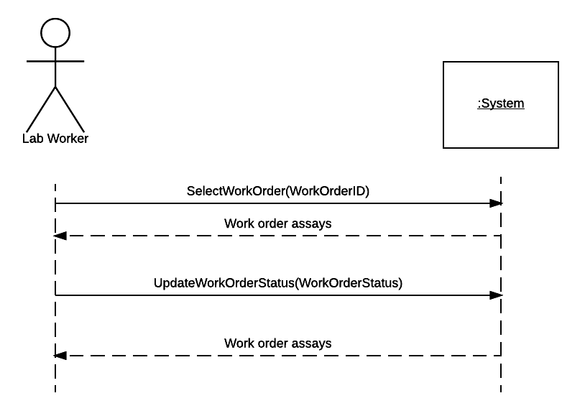

20. View Assay Work Order Status

|  |  |  |
| --- | --- | --- |
| **Use Case Name** | View Assay Work Order Status | |
| **Scenario** | Customer wants to check on the status of the Assay that they sent to Singapore | |
| **Triggering Event** | None | |
| **Brief Description** | When lab workers in Singapore change the status of the work order, the customer should be able to see the updated status from their customer portal | |
| **Actors** | Customer | |
| **Related Use Cases** | Update Assay Work Order Status | |
| **Stakeholders** | Lab Worker, Lab Manager, Management, Customer | |
| **Preconditions** | Work order status has to be set | |
| **Postconditions** | The customer is updated on the status of the work order. | |
| **Flow of Events** | **Actor** | **System** |
| 1. Customer selects order to view in their orders | 2.1 System displays all assays in the work order, and updated progress report. |
| **Exception Conditions** | None | |

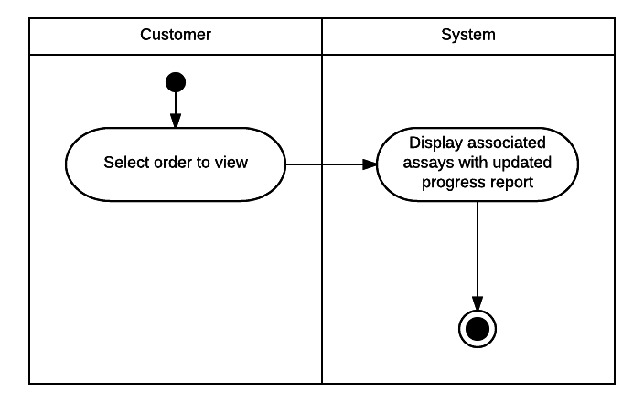

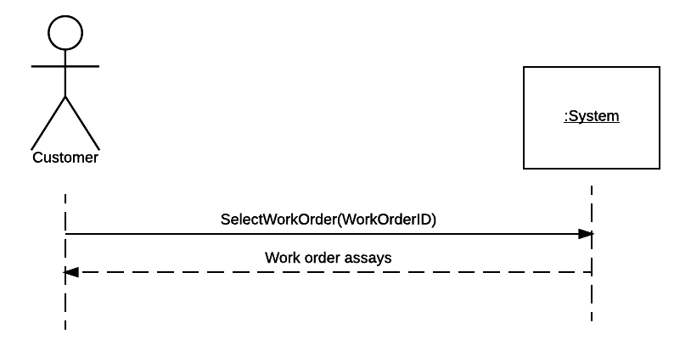

21. Send Compound Receipt Confirmation

|  |  |  |
| --- | --- | --- |
| **Use Case Name** | Send Compound Receipt Confirmation | |
| **Scenario** | Lab workers have received the Compound from the customer order, and need to send a confirmation email to the customer | |
| **Triggering Event** | Lab worker receives compound in Singapore | |
| **Brief Description** | The customer wants to know when their compound is received by the Lab in Singapore. When the compound is received a lab worker marks the compound as received in the Order and the system sends an email confirmation to the Customer | |
| **Actors** | Lab Worker | |
| **Related Use Cases** | None | |
| **Stakeholders** | Lab Worker, Lab Manager, Management, Customer | |
| **Preconditions** | Lab worker receives compound | |
| **Postconditions** | Customer receives email confirmation from the Singapore lab | |
| **Flow of Events** | **Actor** | **System** |
| 1. Lab worker selects associated work order for the customer  2. Lab worker clicks button to mark receipt of compound  3. Lab worker accepts confirmation | 1.1 System displays screen for work order including option to mark receipt of compound  2.1 System asks for confirmation  3.1 System saves receipt of compound time and date  3.2 System sends receipt of compound to email address on file for associated customer. |
| **Exception Conditions** | 2.1 Lab worker does not choose to confirm, compound receipt is not saved and email is not sent. | |

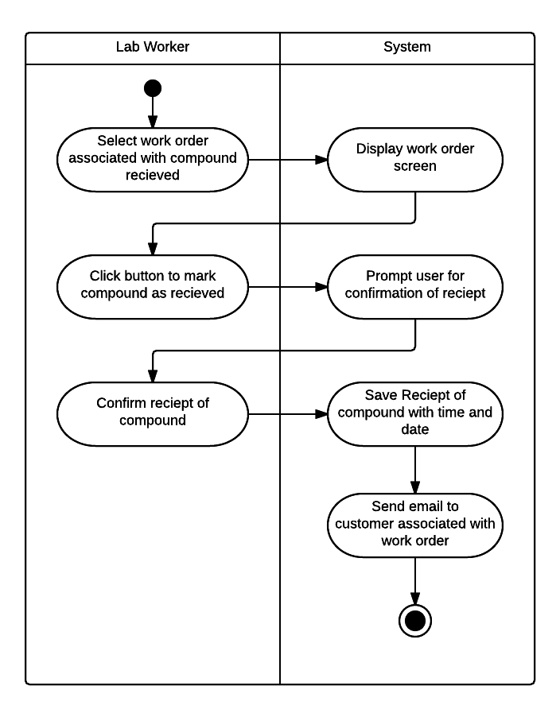

25. Update Work Order Details For Assay

|  |  |  |
| --- | --- | --- |
| **Use Case Name** | Update Work Order Details for Assay | |
| **Scenario** | Lab workers update the work order details for the different assays | |
| **Triggering Event** | Assay is completed | |
| **Brief Description** | The work order details include the materials used for each assay and compound and their prices, the hours worked multiplied by the hourly charge rate set by management, and the base price for the assay. The billing department will use this information to create invoices | |
| **Actors** | Lab Worker | |
| **Related Use Cases** | View Work Order Details | |
| **Stakeholders** | Lab Worker, Lab Manager, Management, Billing | |
| **Preconditions** | One assay in a work order has been completed and needs to have the work order details | |
| **Postconditions** | The Assay work order details for that assay are completed and can be seen by lab workers, lab managers, and the billing department | |
| **Flow of Events** | **Actor** | **System** |
| 1. Lab Worker selects work order to view  2. Lab worker selects “Details” for Assay  3. Lab worker enters details for materials used and hours worked.  4. Lab worker clicks to save | 1.1 System shows all associated assays for work order  2.1 System displays work order details for selected assay.  3.1. System calculates price for hours worked using hourly charge rate, and gets price for materials used.  4.1 System saves and displays work order details with updated materials, hours, and their prices along with base price, and total. |
| **Exception Conditions** | 2.1 Lab worker does save work order details. System does not save or update work order details. | |

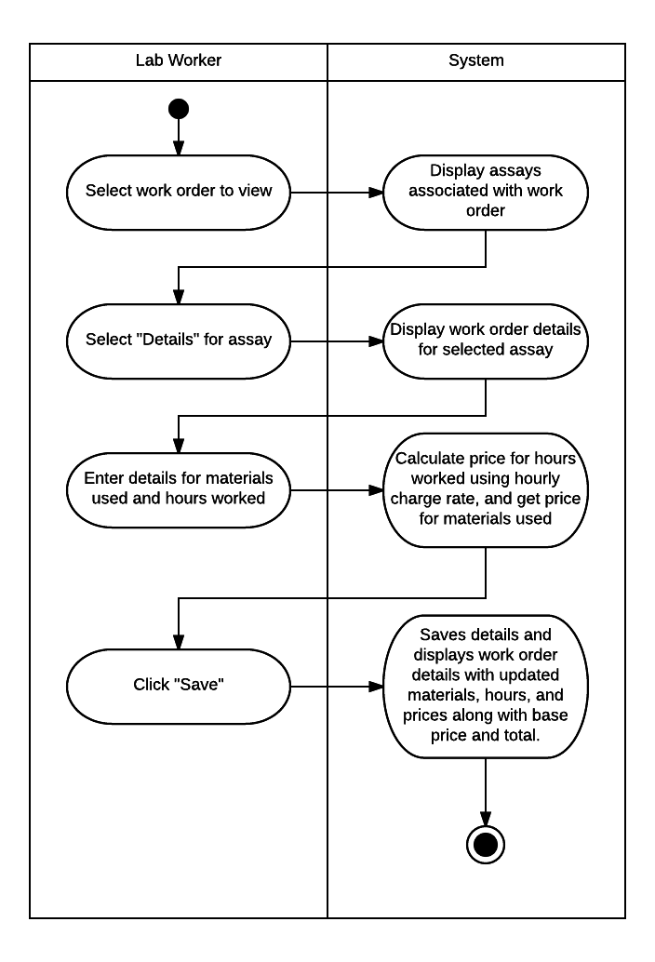

27. Create Further Test Recommendation

|  |  |  |
| --- | --- | --- |
| **Use Case Name** | Create Further Test Recommendation | |
| **Scenario** | Lab workers are recommending further testing to the customer on a selected compound | |
| **Triggering Event** | Assays for a work order are finished and new tests are recommended | |
| **Brief Description** | When Assays are finished lab workers can give recommendations to the customer to perform further tests. The customer can then choose to approve those new tests. | |
| **Actors** | Lab Worker | |
| **Related Use Cases** | View Further test recommendation, Approve further test recommendation | |
| **Stakeholders** | Lab Worker, Lab Manager, Management, Customer | |
| **Preconditions** | Work Order is completed, and further tests are recommended | |
| **Postconditions** | Customer receives an email and can see on the order further recommended tests. They can choose to approve or decline the further tests. | |
| **Flow of Events** | **Actor** | **System** |
| 1. Lab Worker selects correct work order from list of current work orders  2. Lab worker selects assay  3. Lab worker selects option to suggest further test  4. Lab worker selects assay types and enters explanation  5. Lab worker confirms | 1.1 System displays work order and related assays  2.1 System displays assay information and option to suggest further tests  3.1 System displays assay types  3.2 System displays text box for explanation.  4.1 System calculates and displays price and asks for confirmation  5.1 System saves further recommendations  5.2 System sends email to customer asking for approval |
| **Exception Conditions** | 4.1 Lab worker decides not to confirm. The further recommendations will not be saved, and no email will be sent to customer | |

30. Approve further Test Recommendation

|  |  |  |
| --- | --- | --- |
| **Use Case Name** | Approve further test recommendation | |
| **Scenario** | Lab worker has recommended further tests for the assay, and the customer can decide if they want to accept or decline those recommendations | |
| **Triggering Event** | Lab worker has recommended further tests for the assay | |
| **Brief Description** | If further tests need to be run on a compound, a lab worker will enter in a recommendation for further tests. The customer can then see those recommendations and approve or decline those tests. This description shows how the customer can accept and approve the test recommendation | |
| **Actors** | Customer | |
| **Related Use Cases** | Create Further Test Recommendation, View further test recommendation | |
| **Stakeholders** | Customer, Lab Worker, Lab Manager, Management | |
| **Preconditions** | Lab worker has submitted a further test recommendation, and customer can see that recommendation | |
| **Postconditions** | Recommendations are added to the work order and bill is updated with price of new tests | |
| **Flow of Events** | **Actor** | **System** |
| 1. Customer selects work order from list of current work orders.  2. Customer selects link for further test recommendations  3. Customer confirms further test recommendation | 1.1 System shows each assay and its progress  1.2 If lab worker has sent a further test recommendation system shows link for the recommendation  2.1 System displays assay types, explanation from lab worker, and associated price for further tests.  2.2 System displays confirm or decline further test recommendation  3.1 System sends confirmation email to customer  3.2 System adds new assays to work order and to preliminary schedule. |
| **Exception Conditions** | 3.2 Customer declines further test recommendation. System does not add new assays to work order or to preliminary schedule. | |

35. View Completed Reports

65. View Individual Assay Completion Time

74. Create Profitability Reports

82. Create Ad-Hoc Report

90. Create Assay Summary Report

93. Compile All Report Data